16.60: a) b) The frequency will be proportional to the speed, and hence to the square root of the Kelvin temperature.
The temperature necessary to have the frequency be higher is

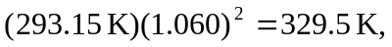

which is 